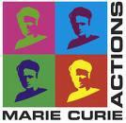
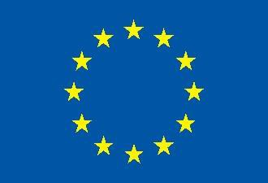

This project has received funding from the European Union Horizon 2020 Programme for research, technological development and demonstration
IODA
Mini-Symposium
11th to 14th June 2018
University of Glasgow

ADJOINT METHODS FOR OPTIMISATION, MESH ADAPTATION AND UNCERTAINTY QUANTIFICATION

The adjoint method is recognised as the most efficient method to compute gradients for numerical optimisation, mesh adaptation, or uncertainty quantification. The adjoint approach has been adopted by major European industries, research institutions and commercial vendors, a range of open-source adjoint solvers is also available, all generating a wide range of applications.
The focus of this minisymposium is to review the recent progress in computing and applying adjoint sensitivities in CFD, CSM and related disciplines.
Contributions will include:
• Improving robustness and versatility of adjoint solvers
• Adjoints for unsteady models
• Adjoints for complex physics and multi-disciplinary systems
• Integration into the workflow with parametrisation, optimisation and return to CAD
• Adjoint methods in uncertainty quantification
• Error analysis and adjoint-driven mesh adaptation
• Applications of adjoint design in industrial cases.

