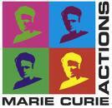
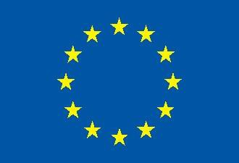
This project has received funding from the European Union Horizon 2020 Programme for research, technological development and demonstration

IODA - 40M Final Steering Committee Meeting
June 15, 2018
Agenda

Gilbert Scott Conference Suite 356
University Avenue
Glasgow
G12 8QQ

The University of Glasgow is a 30 minute walk or 10 minute taxi journey from the ECCOMAS Conference

